Galactic Expo 2020
May 16-17, 2020
At The Fairgrounds Nashville in the NEW EVENTS BUILDING!
500 Wedgewood Avenue, Nashville, TN 37203

Hello Exhibitors,

We are now accepting applications for the 22st Galactic Expo to be held May 16-17, 2020 at The Fairgrounds Nashville.

The purpose and mission of the Galactic Expo is to promote education and awareness of holistic health, natural healing, conscious living, and spirituality. One way we do this is by bringing together alternative health practitioners, great information resources, intuitive readers of all kinds, spiritual counselors, retailers, light workers, vendors and others in one place, allowing them to come together for the health and wellness of body, mind, and spirit.

Attendance at our 2019 Expo was 2504. This is down from our previous year and vendors still had a successful show.

Applications for 2020 started coming in during expo weekend. We were 90% booked for next year by the time the show ended. We will be sold out again by the end of May and expect another extensive wait list. If you are interested in doing the show, please submit an application. We had cancellations as late as setup day.

Current vendors have first opportunity to sign up for next year. We will begin placing new vendors in August from all applications submitted. Upon receipt of application you will be notified if you have a space or are on our wait list. We always have booths that cancel between now and the month of the show. We fill booth space from our wait list.

We are moving into the new buildings at the fairgrounds that are still under construction and expected to be complete by the end of summer. When complete, we will be able to get in to do physical measurements of our space. Once that happens, we will adjust the floorplan and post a more accurate layout. We do expect there to be some changes.

If you are new to the Galactic Expo, we have been at the fairgrounds for all 21 of our previous shows. All the old buildings are coming down this summer to make way for the new soccer stadium that will begin construction this year.

An artist drawing of the new event buildings is included in this document. If you have been with us before, note that the curved track you see on the picture is a representation of the race track that is remaining. The new buildings are not that close to the track. It was included in their drawing to indicate the location of the new buildings on the property.

A completed application and payment in full are required to hold your space. Exhibitors may, as always, sign up anytime. Booths will be assigned, as long as, there is availability in your category.

We have a flexible payment plan and a great cancellation policy!

We keep a balance of vendors in all categories: Alternative Practitioners, Massage & Energy work, Aromatherapy, Astrology, Aura Photography (full), Gifts, Crystals (full), Jewelry, Health & Nutrition, and Psychics (almost always full).

As a space opens, we will fill it from a vendor in the same category. Your payment will be held until we ask you to fill a space.

Applications are not carried over from year to year. You must send in a new form for each show.

We look forward to having you join us for a wonderful 22nd Galactic Expo!

Abundant Blessings,
Katherine
Katherine King
www.GalacticExpo.com
katherine@galacticexpo.com
PO Box 42
Arrington, TN 37014
615-463-7677
615-582-7099
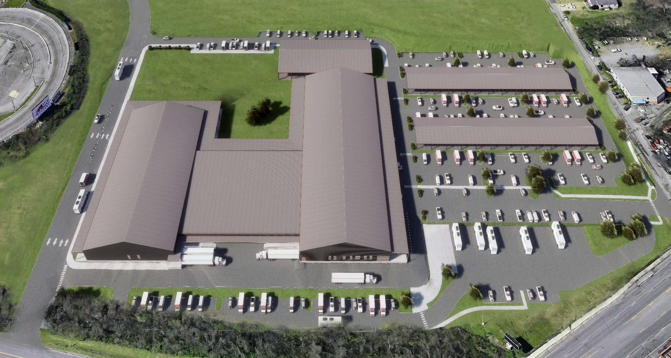
Artist aerial view of new expo buildings at Fairgrounds Nashville
Expected completion date: Summer 2019
Beginning in 2020, The Galactic Expo will be in the Expo 1 building.
Parking is permitted under the open sheds.
Approximately 850 parking spaces at the buildings.
Other parking is in within the same walking distance as previous shows at the fairgrounds.

New tables, chairs and pipe & drape (black only) is expected to be in place by next year.
Expo 1-2-3 are connected in the same way as current buildings, via roll-up doors and an entry door or two.
As the buildings get complete, we will do physical measurements and update the application.

The first game in the new, yet-to-be-built, soccer stadium will be scheduled for 2022.
All current fairgrounds buildings will be razed and replaced with the new soccer stadium and related structures.
Galactic Expo 2020
Open Shed. Ok to use for parking
Open Shed. Ok to use for parking
Expo 3
Expo 2
Expo 1
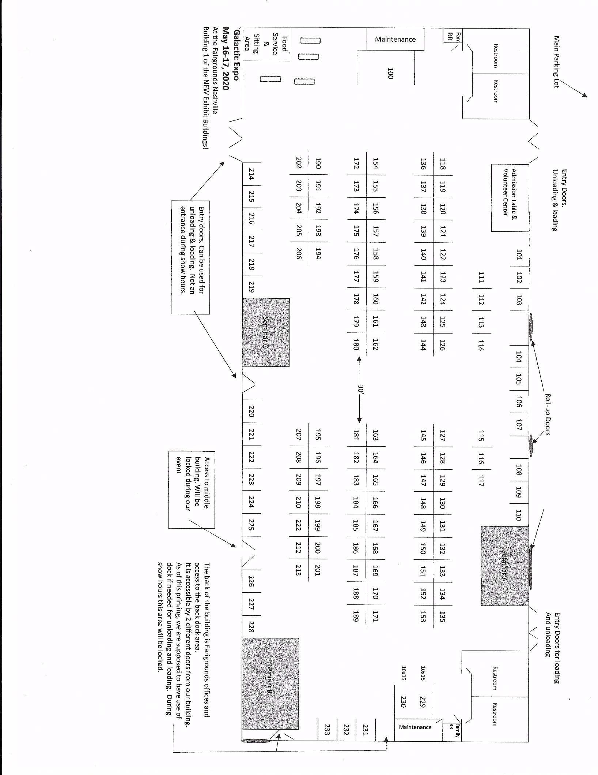
Full Page ad.
$160
Max of 7”w x 9 1/2”h

Half-page Vertical Ad
$130
Max of 3 1/4”w x 9 ½ ” h

Horizontal Business Card ad:
$40
Max of 3 ¼”w x 2”h

.

Vertical Business Card Ad
$40
Max of 2”w x 3 ¼”h

Half-Page Horizontal Ad
$130
___ Max of 7”w x 4 ¼”h_______

Advertising Rates
Galactic Expo
Program is printed in B&W
Available online in color.

Ads must be Copy Ready
Deadline: January 31, 2020

Email to:
katherine@galacticexpo.com

Format:
Microsoft Publisher, jpg, gif, pdf
Microsoft Word

Ad Prices:
$40 $80 $130 $160

615-582-7099

Quarter Page Ad
$80
Max of 3 ¼”w x 4 ¼”h

Contract, Terms, & Conditions

The Galactic Expo
Changes from last year’s application are hi-lighted

Date and Location:
- May 16-17, 2020
- In the NEW EVENTS BUILDING – BUILDING 1 ~ The Fairgrounds Nashville, 500 Wedgewood Avenue, Nashville, TN 37203
Set-Up / Check-In / Show Schedule / Break-Down:
- Set up: is from 9am to 7 pm CST on Friday.
- Check in: Prior to setting up, register at the admission table at the main entrance to pick up ID badges and vendor packets.
- Unloading on Friday and Loading on Sunday: Easy access will be marked on the updated floorplan.
- On Saturday & Sunday: FOR SECURITY REASONS: only the main entrance doors can be used for entry or exit from the buildings.
- Show Hours: Saturday 10am – 7pm. Sunday 10am - 5pm. Nashville is on Central Time – CST.
- Doors will open for exhibitors at 8:00am on Saturday and Sunday
- Be set up and ready by 9:45am each day.
- Break Down: Booths need to remain active through 5pm on Sunday. Leaving early without prior arrangements may prevent you from having the ability to participate in a future show. You must be packed and out of the building by 11:00pm on Sunday.
Booth Pricing and Booth Choices:
- All booths, unless marked otherwise on the floorplan, are 10’ x 10’ and are $330 each.
- Prices for the over-size booths are marked on the floorplan. There could be more once we are able to do final measurements in the new building.
- This is a 2-day event. The booth cost is for both days.
- No multiple booth discounts are available.
- Booth assignments have already begun for returning vendors.
- New vendors are accepted now and placed beginning July 1st.
- You may enter booth choices on your application. We will place you as close as we can to your choice. We keep a balance of vendors in all categories. If the maximum is reached in your category, we will keep you on our cancellation / waiting list and notify you that you are on that list.
- A completed application and payment in full or post-dated payment(s) in full is required to reserve your booth.
- A completed application and payment / payment arrangement is required to place you on the waiting list.
- Your checks or payments will not be deposited until you have been assigned a booth.
- Applications are not carried over from year to year. A new application is required for each show.
Miscellaneous Information:
- We do offer exclusivity to some products and services. All products and services offered in your booth must be approved by the show. You must notify the show of all products and services you will be offering, even if you do not want them listed in the program or on the expo website.
- All exhibitors must complete an application.
- All sharing exhibitors must complete an application. Shared booths also share the 30-word description limit for the program.
- ALL FOOD & DRINK samples must have prior approval of the fairgrounds. Concession is provided by the fairgrounds.
Each booth comes with:
- All booths are 10’ x 10’ and come with pipe and drape. The fairgrounds is getting new black drape. Colors will no longer be available.
- Wall booths have 8’H drape at back and 3’ Hat sides. Some aisle booths will have 8’H draping at the back. Others will have only 3’H draping.
- Metal folding chairs provided as needed.
- One rectangular table. Tables are 6’ x 2 ½’ or 8’ x 2 ½’. Tables are not skirted. You will need to provide table covering.
- One 8 ½” H x 14” W white cardstock booth sign.
- One table of contents listing per sign.
- Up to four ID Badges per booth for you, your sharing vendor and booth workers. Additional ID badges available at $5 each
- One 30-word description per booth for the printed program.
- One 100-150 word description per exhibitor for the Galactic Expo website. Please submit a picture for the website.
Electricity:
- For all booths: Cost is $25 if ordered before April 1st, $50 after April 1st, and $100 on set-up day.
- Outlets and drops are shared, regardless of location. Bring surge protectors, power strips, and extension cords.
Additional Tables:
- Additional 6’ or 8’ tables are $10 each in advance or $15 each after April 1st.
- Card tables are not provided-please remember to bring your own.
Sharing of Booth Spaces:
- Booths may be shared with show approval only.
- Sub-letting of your booth is not permitted.
- Adding a vendor to your booth without show approval is not permitted.
- Inviting a customer or other healer / reader into your booth during the show to provide services or assist you with yours is not permitted.
- The primary contact person is responsible for all payments or payment arrangements and for informing helpers and others in their booth of all terms and conditions of the show. For anyone sharing your booth, a listing of services and products being offered must be turned in with your application or mailed to us in a timely manner.

The Galactic Expo Office
PO Box 42 Arrington, TN 37014
Contact: Katherine ~ katherine@galacticexpo.com 615-582-7099

Payments:
- Booth payments, fees, and advertising costs may be paid by cash, check, or money order. Make payable to: Galactic Expo and mail to: Galactic Expo PO Box 42 Arrington, TN 37014. Credit card payments are processed through our PayPal account and a 3.5% processing fee will be added to your invoice.
- Payment in full, or PayPal credit card arrangements and a completed application is required to hold your booth.
Booth Cancellations / Refund Policy:
- Full refund if cancellation is done by January 31st.
- 50% refund if cancellation is done by March 31st.
- After April 1st, No Refunds under any circumstances.
- You must check-in by 12pm Friday (unless you have made prior arrangements). If you have not registered, then your booth will be re-assigned and you will forfeit your right to participate in the show and forfeit all fees and monies paid.
$1 OFF Admission Coupons were discontinued, effective with the 2019 show.
- Customers can still get a discount by purchasing tickets online or in person at Cosmic Connections.
- Eliminating the coupon was one way to control other increases to producing the expo.
Lectures / Talks & Workshops:
- 30 lectures / talks are free to the customer, presented free by the exhibitor, and presented at no cost to the exhibitor.
- Each talk is 45 minutes long, including any question and answer period you may want to include.
- Please include a topic and description on your application if you are interested in presenting a lecture.
- Seminars will be finalized in January.
- We offer a limited number of paid presentations and workshops. These are chosen at the discretion of the show, and prices for admission to them are $10 for a 45-minute group gallery / group reading. Submit a topic and description if you would like to be considered for a paid presentation. You may opt to present them for free as well.
Other Information:
- Due to fire and safety regulations, aisles must be kept clear of displays, furniture or other items. All displays and merchandise must be kept inside the allotted space.
- We are not permitted to have open flames or burning incense.
- Signs and advertisements must be kept in allotted space. Banners/signs promoting you or your business may be hung from the draping.
- We are not permitted to tape or pin anything on the walls or doors of the building including in the restrooms and stall doors.
- All exhibitors are expected to keep their exhibit space clean and attractive.
- Exhibitors may not display any object that would be considered offensive or in poor taste and agrees to remove said objects if asked to do so by management.
- All exhibitors are considered independent contractors and all necessary permits, licenses, insurance, credentials, and taxes are the sole responsibility of all participants.
- Each exhibitor is responsible for the security at their booth during expo hours. We provide security during show hours. The building is locked after hours; an alarm system is in place during off hours.
- Alcoholic beverages, illegal substances or illegal activities are not permitted on premises.
- Management expects and requires all exhibitors to behave in a professional and ethical manner at all times. No inappropriate language or body contact is permitted.
- Management reserves the right to ask exhibitors to leave because of unprofessional, unethical, illegal or unacceptable behavior that exhibits gross disrespect for another person or persons and/or their rights and/or property. If exhibitor is asked to leave, all fees, deposits, and payments are forfeited, and they will be prohibited from participating in future events.
- In the event that a show becomes unusable or cancelled due to causes not within our control, exhibitors release The Galactic Expo, Katherine King and all sponsors from all claims, damages, or loss. Refunds will be issued on a pro-rated basis, less all expenses incurred by the show.
- The Galactic Expo reserves the right to determine the eligibility of each exhibitor to participate in the shows. This right may be exercised before or during the show, even if booth deposits or payments have been made.
- Management assumes no risk. By acceptance of this agreement, the Exhibitor agrees to hold harmless Katherine King, The Galactic Expo and any sponsors and releases the Management from any and all liability for damage, injury, or loss to any person, property, or goods, which may arise during or as a result of this event.
***Prices for services are required to be clearly posted***

All exhibitors set their own prices for services and merchandise.
It is your responsibility to collect payment and sales taxes from the customer.
As of this printing, services of the types provided at the Expo are not sales taxable in Tennessee.
Questions? Contact Katherine King: katherine@galacticexpo.com
PO Box 42 Arrington TN 37014. 615-582-7099

Galactic Expo Office
PO Box 42
Arrington TN 37014
615-582-7099
May 16-17, 2020

The Galactic Expo is held at the:
The Fairgrounds Nashville
IN BUILDING 1 OF THE NEW EVENTS BUILDING
500 Wedgewood Avenue, Nashville, TN 37203
- Please type, write or print clearly. Typing into the document will move all text down. Keep typing. Email it to us. We will make adjustments.
- Read terms & conditions, sign application / contract on back.
- Completed application and payment in full is required to hold your space.
- Make checks payable to: Galactic Expo. Mail to: Galactic Expo Office PO Box 42 Arrington, TN 37014
- Booth assignments have already begun. Returning exhibitors will be placed first. New exhibitors placed July 1st.
- Questions? Contact: Katherine 615-582-7099 or katherine@galacticexpo.com

Name on Booth Sign, Program Listing & Expo Website:
(8 ½”h x 14”w cardstock sign. Max 40 letters / spaces for name. Includes 1 table of contents listing. City/State not included in limit.) City/State
Name on Additional Booth Sign. (Cost $5)
Sign includes 1 table of contents listing

 | Description for Program. 30 words per booth even if sharing. Optional: 100-150 words per exhibitor for website. Email a picture for the website.
 | Contact Info for Program & Website Maximum of 3. Ex: Phone, email, website
 | Names for ID Badges: up to 4 included with your booth fee  1.  2. |  |  |  |  | 3.  4.
I would be interested in offering a 45-Minute FREE mini-seminar /presentation / workshop.
30 words or less for program. 100 words for website. Presentations chosen in January based on submissions.

Title:

Description:

I would be interested in offering a 45-Minute FREE mini-seminar /presentation / workshop on a second topic or a Group Gallery / Reading. $10 admission to customers for group readings. If you will offer this presentation for FREE, check here_____.
30 words or less for program. 100 words for website. Presentations chosen in January based on submissions.

Title:

Description:

*We do give exclusivity to some products / services. Be sure to inform the show of all products or services being offered in your booth.
*Group Readings and Workshops: Split 40% to the presenter, 60% to the show.
The Galactic Expo
PO Box 42 Arrington, TN 37014
katherine@galacticexpo.com www.galacticexpo.com
615-582-7099

Booth Choices Floor plan may get adjusted once we get inside the finished building and are able to take actual measurements.
We will do our best to keep you in the area of your choices.

 |  | First Choice |  |  | Second Choice |  |  |  | Third Choice

PROGRAM DIRECTORY CATEGORIES. (One category is included with each booth sign. Additional categories may be purchased for $2 each)

 | Alternative / Bodywork / Energywork / Holistic / Hypnosis / Massage Therapies |  | Each booth comes with one table and
 | Aromatherapy / Candles / Essential Oils / Herbs / Soaps |  | Chairs as needed.
 | Astrology / Aura Photography |  | Please check:
 | Authors / Retreats / Tours / Workshops |  | No table
 | Body / Mind / Spirit / Spiritual |  | 6’ table
 | Books / Gifts / Clothing |  | 8’ table
 | Crystals / Jewelry |  | No chairs
 | Health Information / Products / Nutrition / Alternative Health Devices |  | Quantity of chairs needed
 | Music / Visionary Art
 | Pet Communicators
 | Psychics / Intuitives / Mediums / Channels

Booth and Additional Fees: Price for oversize booths is marked on floorplan. Usually reserved by returning vendors.
 | Booth Fee: Qty of 10’ x 10’ booths x $330 |  | Each booth includes one booth sign + one directory listing
 | Additional Booth signs x $5 each |  | Extra sign includes one directory listing
 | Additional Directory Listings x $2 each |  | For extra listings over the one(s) included with your sign(s)
 | Additional 6’ table x $10 each |  | Bring table covering
 | Additional 8’ table x $10 each |  | Bring table covering
 | Additional ID badges x $5 each |  | Up to 4 included with booth fee. For helpers / booth mates only.
 | Electricity for your booth x $25 |  | $25 now. $50 after April 1st. $100 at set-up
 | Additional Program Advertising |  |  | $40 Business Card size |  | $130 Half Page
 |  |  |  | $80 Quarter Page |  | $160 Full Page
 | TOTAL DUE
Payment or payment arrangements in full due with your completed application to reserve your booth.
Check(s) can be dated between June 1st and January 31st. Cash is appreciated too.
PayPal Invoices will be sent to you if you need to pay by credit card. Due date is between now and Jan 31.
Send a PayPal Invoice to this email:
Contact Information Notify the Galactic Expo of any address change. You will risk losing your booth if we are unable to contact you:

Name
Address
City/State/Zip
Phone
Cell Phone
E-mail
Website
By signing this contract, I agree that: I have read, understand and agree to abide by the terms and conditions of this contract.
As a primary contact person, I agree to be responsible for all payments and fees and to inform all other exhibitors and helpers in my booth of all terms and conditions.
I have read and understand the Booth Cancellation/Refund Policy
Signature |  |  |  |  |  | Date
Flyers and postcards will be mailed to you to distribute in your area and at other events you attend. Digital versions will be emailed to you for your social media.
 | Quantity of 8 ½” x 11” flyers. |  |  |  | Quantity of postcards.
If you are new to the expo, how did you find out about us? |  | As a customer of cosmic connections

Sign and return completed application, pages 7 & 8 to Galactic Expo. Enclose Payment. Keep all other pages for your records.

For Office Use Only:
6 | 8 | CH | WE | DE | F | PC | PP

