**From I-65, South of Nashville:**

120 Booths!

Agriculture Hall & Banquet Hall

**For GPS Purposes:**

The Fairgrounds Nashville / Address is:

500 Wedgewood Avenue, Nashville, TN 37203

Take I-65 N toward Nashville.

Take the WEDGEWOOD AVE exit- exit number 81.

Turn RIGHT onto WEDGEWOOD AVE.

½ mile to fairgrounds and right at turn-lane into main gate.

**From I-65, North of Nashville:**

Take I-65 S toward Nashville.

Take the WEDGEWOOD AVE exit- exit number 81.

**OPEN SHEDS & PARKING**

PARKING

*(*I-65 & I-40 run together as you get close to Nashville. Exit numbers*

*Jump up for a couple of exits, then drop. Stay on 65. You WILL come to Exit #81)*

Turn LEFT onto WEDGEWOOD AVE.

½ mile to fairgrounds and right at turn-lane into main gate.

**From I-24, East of Nashville:**

**Open Sheds & Parking**

**Vaughn Building**

Take I-24 W toward NASHVILLE.

Merge onto I-440 W.

Take the NOLENSVILLE PIKE exit- exit number 6.

**Rabbit Barn**

Turn RIGHT onto NOLENSVILLE PIKE.

**PARKING**

Go one mile and LEFT onto Walsh / Wedgewood into

the fairgrounds.

¼ mile then left at stop sign into main gate.

**From I-24, West of Nashville:**

Take I-24 E toward NASHVILLE

**Agriculture Hall**

☺

Merge onto I-65 S.

Take the WEDGEWOOD AVE exit- exit number 81.

**Banquet Hall**

☺

Entrance

Restaurant

Turn LEFT onto WEDGEWOOD AVE.

½ mile to fairgrounds and right at turn-lane into main gate.

**From I-40, West of Nashville:**

**Wilson Hall**

**Judging Arena**

Take I-40 E toward NASHVILLE.

Merge onto I-440 E.

Take the NOLENSVILLE PIKE exit- exit number 6.

Turn LEFT onto NOLENSVILLE PIKE.

Go one mile and LEFT onto Walsh / Wedgewood into

**PARKING**

the fairgrounds.

¼ mile then left at stop sign into main gate.

**Grandstand / Racetrack**

**Exhibitor’s Building**

Fairgrounds / Flea Market Office

**Creative Arts**

**Building**

**From I-40, East of Nashville:**

**PARKING**

Take I-40 W toward NASHVILLE.



Merge onto I-24 E

Merge onto I-440 W.

**PARKING**

Take the NOLENSVILLE PIKE exit- exit number 6.

Turn RIGHT onto NOLENSVILLE PIKE.

Go one mile and LEFT onto Walsh / Wedgewood into

the fairgrounds.

¼ mile then left at stop sign into main gate.

*Wedgewood Avenue runs through the fairgrounds

and turns into Walsh when it meets Nolensville Pike.

You will see the fairgrounds buildings.

Turn at Rains Avenue into the fairgrounds.

Rains Ave

Turn LEFT past the Creative Arts Building which is the

Walsh / turns into Wedgewood

To I-65

first large building on your left—

The Agriculture Hall is on the immediate right.

We are in the **AGRICULTURE HALL & BANQUET HALL**

Address is: 500 Wedgewood Avenue, Nashville TN. 37203

**May 19-20, 2018**

Buildings are clearly marked.

Convenient parking is available to the left side

and in the area behind the Banquet Hall building.

**There is an 8’ high banner on the front**

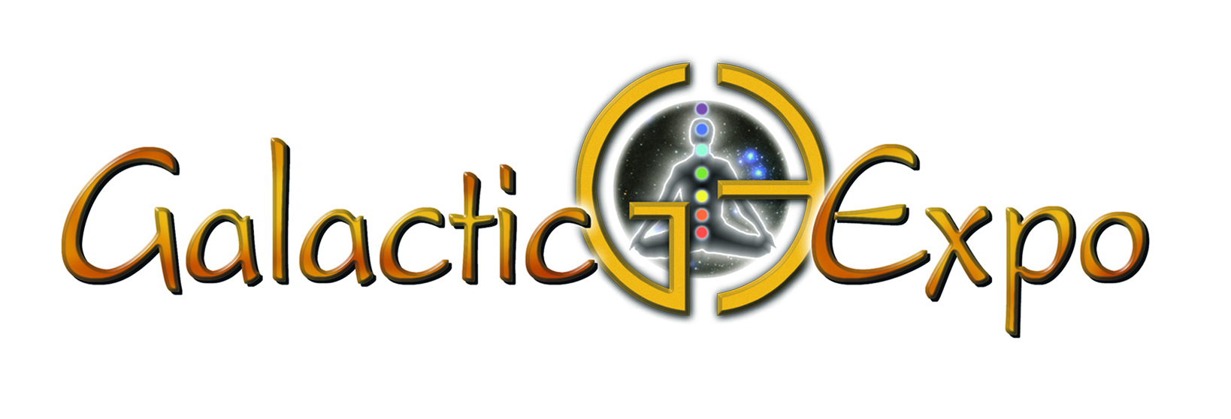

**of our building that says: “Galactic Expo”**